**(1)**

1. **Title:** [Truth of Varying Shades: Analyzing Language in Fake News and Political Fact-Checking](https://homes.cs.washington.edu/~eunsol/papers/factcheck_emnlp17.pdf)
2. **Author:** Hannah Rashkin, Eunsol Choi, Jin Yea Jang, Svitlana Volkova, Yejin Choi
3. **Publisher/Year:** EMNLP 2017
4. **Resources:** [Website](https://homes.cs.washington.edu/~hrashkin/factcheck.html)(has lexicon), [Github](https://github.com/manishmotwani3/fakenews)
5. **Abstract:** It compares the language of real news with that of satire, hoaxes, and propaganda to find linguistic characteristics of the untrustworthy text.
   1. Satire: mimics real news but still cues the reader that it is not meant to be taken seriously
   2. Hoax: convinces readers of the validity of a paranoia-fueled story
   3. Propaganda: misleads readers so that they believe a particular political/social agenda
6. **Approach**
   1. Applied lexical resources and compare the ratio (unreliable/reliable) btw lexicon markers
      1. Linguistic Inquiry and Word Count ([LIWC](https://www.cs.cmu.edu/~ylataus/files/TausczikPennebaker2010.pdf))
         1. Related paper: The psychological meaning of words: LIWC and computerized text analysis methods
            1. Deceptive statements are moderately **descriptive**, distanced from self, and more **negative**.
            2. Use more **negative emotion**, more **motion** words (e.g. arrive, car, go), fewer exclusion words, and less first-person singular (fewer third-person pronouns)
            3. Use **higher total word count**, less first-person singular, and more **sense words**.
            4. Shows **less diversity** and complexity(exclusive words = a marker of complexity)
      2. Sentimental lexicon - strongly and weakly subjective words
      3. Lexicons for hedging
      4. Intensifying lexicons

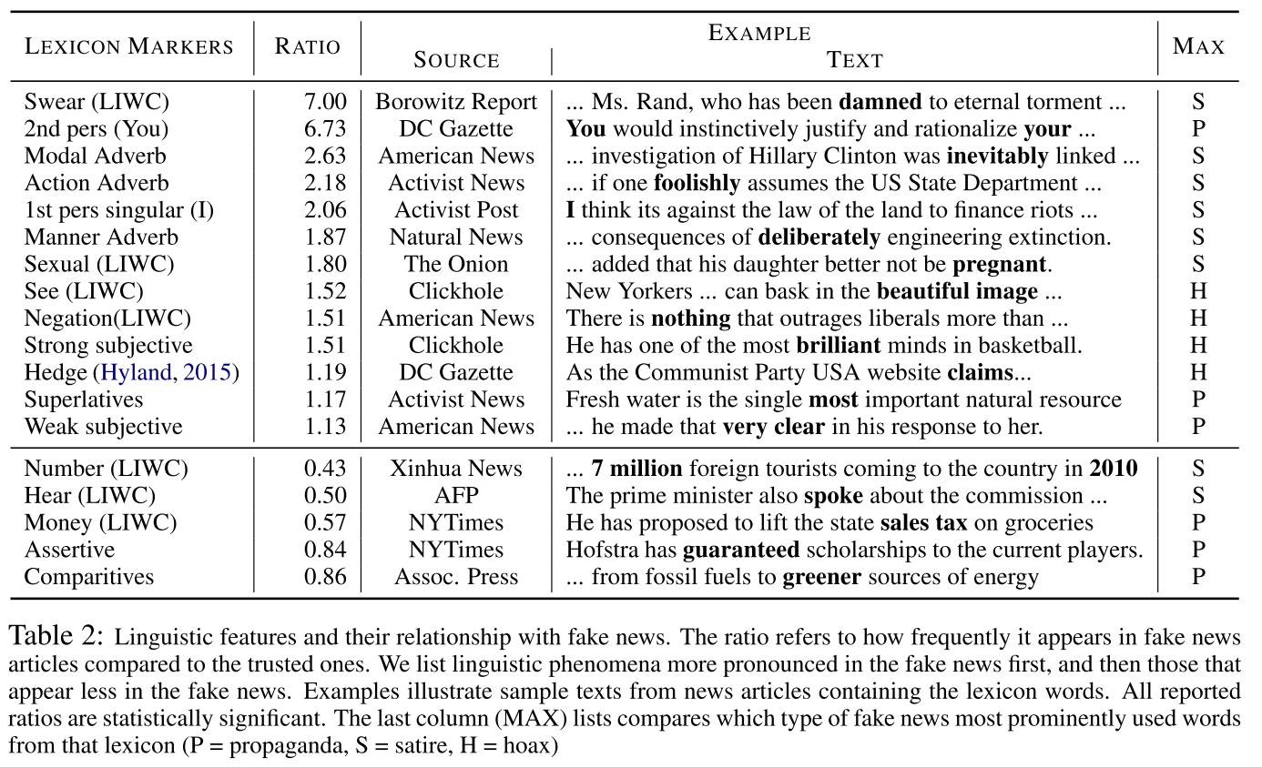

* 1. Findings
     1. First-person and second-person pronouns are used more
     2. More exaggerating words - subjectives, superlatives(highest, biggest, etc), modal adverbs. VS comparative (more than, as ... as)
     3. Trusted sources are more likely to use assertive words and less likely to use hedging words (less vague in describing)
     4. Satire: prominent use of adverbs
     5. Hoax: use fewer superlatives and comparatives
     6. Propaganda uses more assertive verbs and superlatives.

1. **Prediction Method**
   1. **Data:** Articles from **Politifact.com** (total 4,366 statements)
      1. 6-class(True, Mostly/Half True, False, Mostly Fase, Pants-on-fire)
      2. 2-class(True, False)
   2. **Model**
      1. (Baseline) **Maximum Entropy** (MaxEnt), **Naive Bayes**
         1. Input: Word tf-idf vectors / LIWC measurement + [tf-idf](https://en.wikipedia.org/wiki/Tf%E2%80%93idf)
      2. LSTM
         1. Input: 100-dimensional word embeddings from **GLOVE**
         2. Hidden layer = 300, batch_size = 64, Adam, epoch = 10
2. **Result**

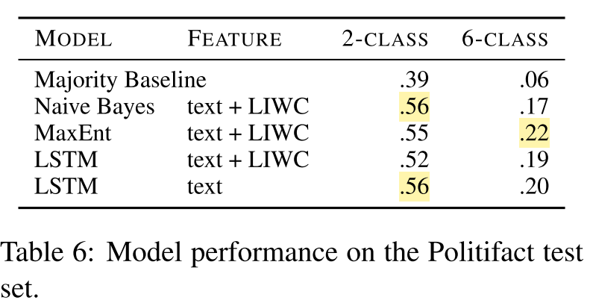

**(2)**

1. **Title:** Efficient Estimation of Word Representations in Vector Space
2. **Author:** Tomas Mikolov, Kai Chen, Greg Corrado, Jeffrey Dean
3. **Publisher/Year:** Corr 2013
4. **Abstract:** It proposes two models for computing continuous vector representations of words from very large data sets. (measured in a word similarity task)
5. **Method**

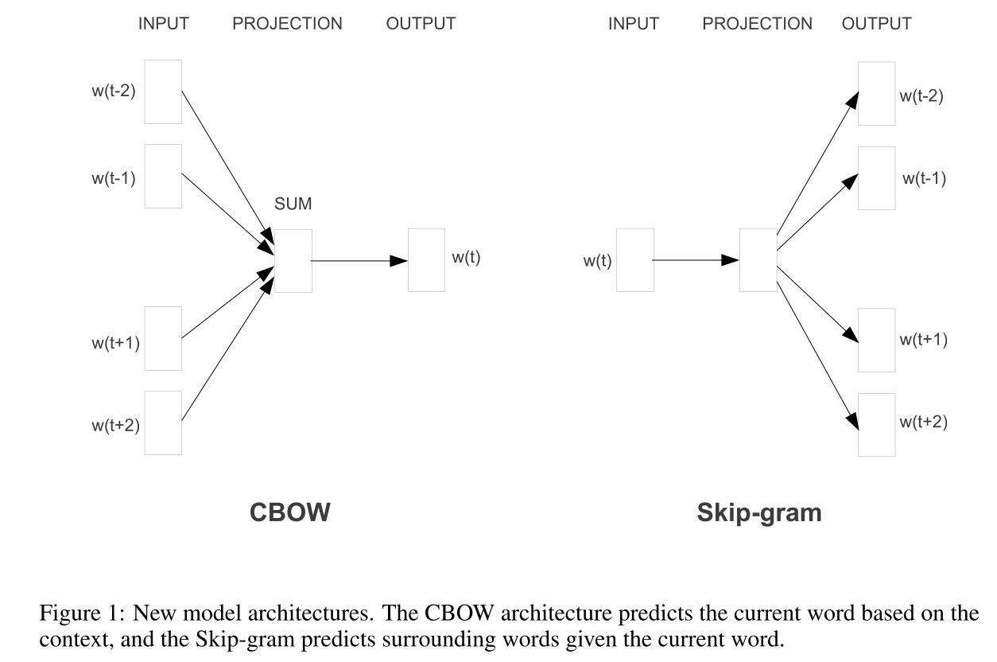

**(3)**

1. **Title:** [Fake News or Truth? Using Satirical Cues to Detect Potentially Misleading News.](https://www.researchgate.net/publication/301650504_Fake_News_or_Truth_Using_Satirical_Cues_to_Detect_Potentially_Misleading_News)
2. **Author:** Victoria L. Rubin, Niall J. Conroy, Yimin Chen, and Sarah Cornwell
3. **Publisher/Year:** NAACL-HLT 2016
4. **Abstract:**
   1. Satire is a type of deception that intentionally incorporates cues revealing its own deceptiveness.
   2. Conceptual overview of satire and humor, elaborating the unique features (absurdity, humor, grammar, negative affect, and punctuation) of satirical news.
5. **Approach:** Collected and analyzed a dataset of 360 news articles.
   1. **Data-Driven Linguistic Observation**
      1. Absurdity and Humor:
         1. The satirical articles tend to repeat the same materials from the title in the first line.
         2. The final line was commonly a "punchline" that highlighted absurdities in the story or introduced a new element to the joke
         3. Observed a high frequency of slang and swear words in the satirical news.
      2. Sentence Complexity:
         1. tend to pack a greater number of clauses into a sentence for comedic effect. (-> increase in # of punctuation marks. / grammar = the complexity of phrasing)
   2. **Satire Detection Approach and New Satire Features**
      1. Based on the previous observation, it proposed and tested a set of 5 satirical news features: Absurdity, Humor, Grammar, Negative Affect, and Punctuation.
      2. Performing a topic-based classification → sentiment-based classification → feature selection based on absurdity and humor heuristics.
      3. **Support Vector Machines (SVM)**
         1. 10-fold cross-validation.
         2. Input - a sparse feature vectors using a topic-based classification with tf-idf weighing scheme.
         3. Preprocessing
            1. Stop words were removed → unigram and bigrams were tokenized → training/test data were converted to tf-idf feature vectors → term frequency values were normalized by article length
         4. Feature selection.
            1. Absurdity: an unexpected introduction of new named entities (people, places, locations) within the final sentence of news.
            2. Humor: the lead and final sentence are minimally related. (so, how to measure the relatedness? used Wu & Palmer's word-to-word similarity metric. and compare each word in S1 and S2.)
            3. Grammar: the set of normalized term frequencies matched against the LIWC dictionaries. (counts for adjectives, adverbs, pronouns, etc), which accounts for the percentage of words that reflect different linguistic categories.
            4. Negative affect / Punctuation: were assigned as feature weights.
6. **Result**

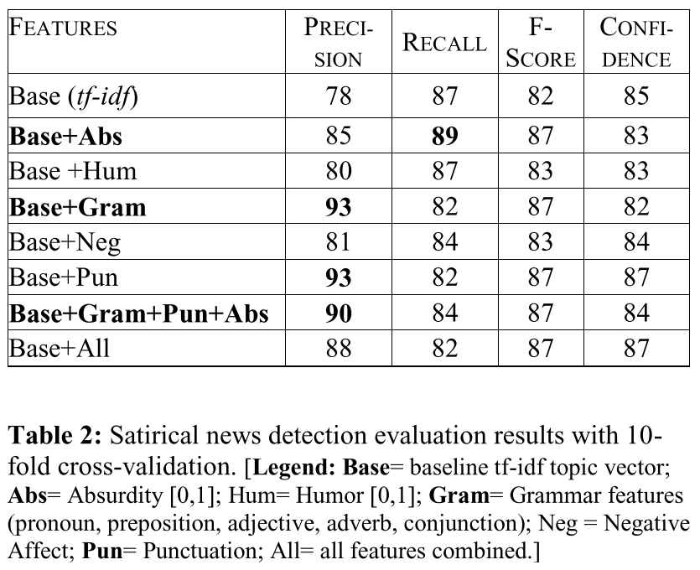

**(4)**

1. **Title:** Politifact Language Audit Dallas
2. **Author:** Dallas Card,∗ Lucy H. Lin,† and Noah A. Smith†
3. **Publisher/Year:** 2018
4. **Abstract:** Report on automated text analysis tools to identify possible biased treatment by Democratic vs Republican speakers, through language.
5. **Approach**
   1. **The goal** is to isolate differences in tone or stance or style rather than concentrating on the differences in content.

(5)

Title: [Text Categorization with Support Vector Machines: Learning with Many Relevant Features Thorsten](https://link.springer.com/chapter/10.1007/BFb0026683)

* The most citation for SVM

Why SVM for text classification?

1. Independent of the dimensionality of the feature space

* SVMs measure the complexity of the hypothesis based on the margin with which they separate the data, not the number of features
* SVMs use overfitting protection, which does not necessarily depend on the number of features, they have the potential to handle these large feature spaces

2. Few irrelevant features in text classification

* SVM eliminate the need for feature selection
* Naive Bayes works with feature selection, and it may result in a loss of information

3. Document vectors are sparse

4. most text categorization problems are linearly separable

In order to mitigate the effects caused by the proliferation of fake news online, it is important todetect them before it reaches many. Many researchers have provided predicting models for deceptivedetection [cite] but no one has evaluated [add our new approach.. if there’s any..] In this project, weattempted to predict fake news by using various word vectorization methods (bag-of-word, TF/IDF,and Word2Vec)upon which Natural Language Processing techniques are applied. We further examinethe sentiment features added to the word-embedding and deep learning model combination to see itspotential to increase the prediction accuracy